Join your Club Course neighbors at the annual CCPOA Spring Social Happy Hour sponsored by your CCPOA Board. Don’t miss this opportunity to meet your Board members and chat with new and old neighbors, all while enjoying light appetizers, beer and wine, and surrounded by the beauty that is Sea Pines.

**When: May 30, 2025**

**Where: Tower Beach Pavilion**

**Time: 5:30 pm - 7:30 pm**

This event is free to all Club Course POA members. Not a member yet? It’s not too late to join! Membership dues are only $35. Just bring a check to this event, use your bank’s electronic bill pay, or mail your check to CCPOA, PO Box 6271, HHI, SC 29938– 6271

This year we will be collecting donations for the **Hilton Head Island Humane Society**. They are always in need of donations of food, treats, leashes, toys, beds, and carriers. For a complete list of the Society’s specific needs please see the attached list or visit their website at hhhumane.org.

Any questions about this event or the CCPOA contact Linda Fraser, Board President, at lsf31759@gmail.com.

**We hope to see you at this great event!**

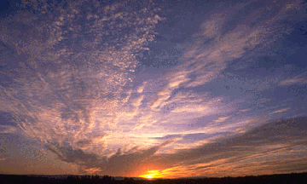

**Club Course POA**

**Annual Spring Social Happy Hour**

PO Box 6271

HHI, SC 29938-6271

clubcoursepoa.com

Email: lsf31759@gmail.com